**DAILY ONLINE ACTIVITIES SUMMARY**

|  |  |  |  |  |  |  |  |
| --- | --- | --- | --- | --- | --- | --- | --- |
| **Date:** | 06-06-2020 | | | | **Name:** | Gudugunti Anirudh | |
| **Sem & Sec** | IV - A | | | | **USN:** | 4AL18CS023 | |
| **Online Test Summary** | | | | | | | |
| **Subject** | | Data communication | | | | | |
| **Max. Marks** | | 30 | | **Score** | | 26 | |
| **Certification Course Summary** | | | | | | | |
| **Course** | **Python for ML** | | | | | | |
| **Certificate Provider** | | | Great learning academy | **Duration** | | | **2 hr** |
| **Coding Challenges** | | | | | | | |
| Problem statement:1Program to rotate an array by N positions | | | | | | | |
| **Status:** completed | | | | | | | |
| **Uploaded the report in Github** | | | | yes | | | |
| **If yes Repository name** | | | | https://github.com/alvas-education-foundation/anirudh_gudugunti/tree/master/daily_progress | | | |
| **Uploaded the report in slack** | | | | yes | | | |

**Online Test Details: The topic** is module 5 of Subject Data communication. The questions were all multiple-choice questions which were optimal and easy to solve. The score that I got was 26/30.

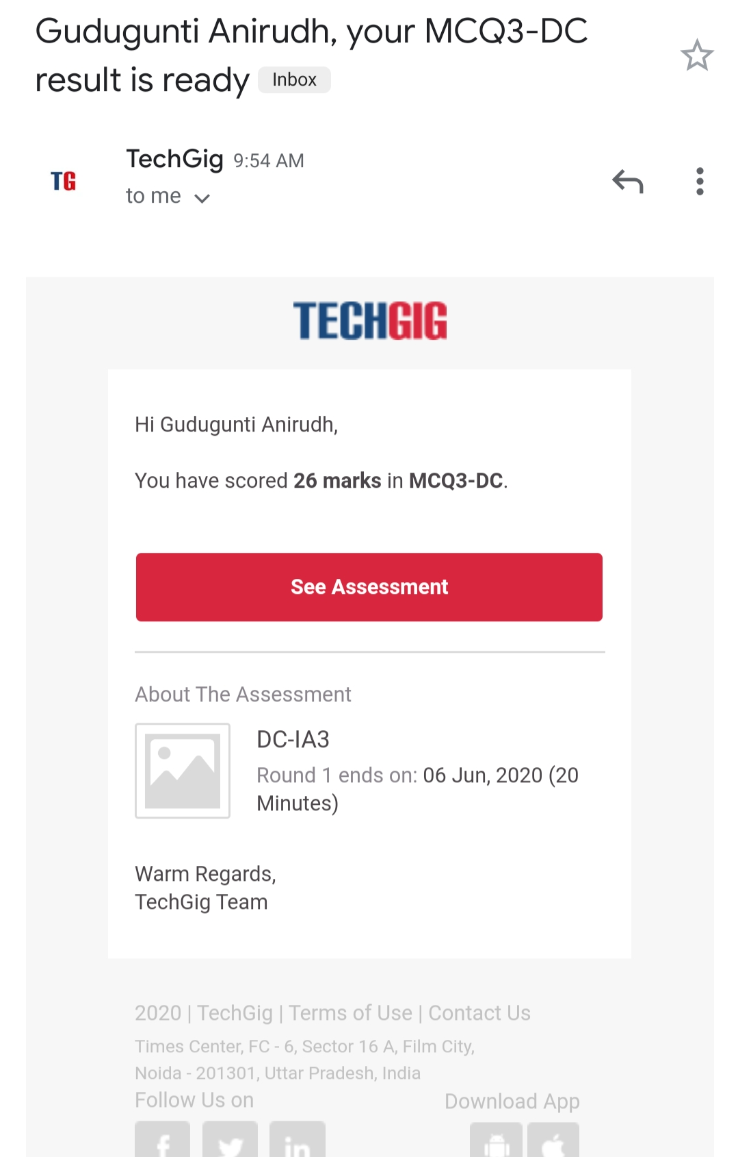

Certification Course Details:

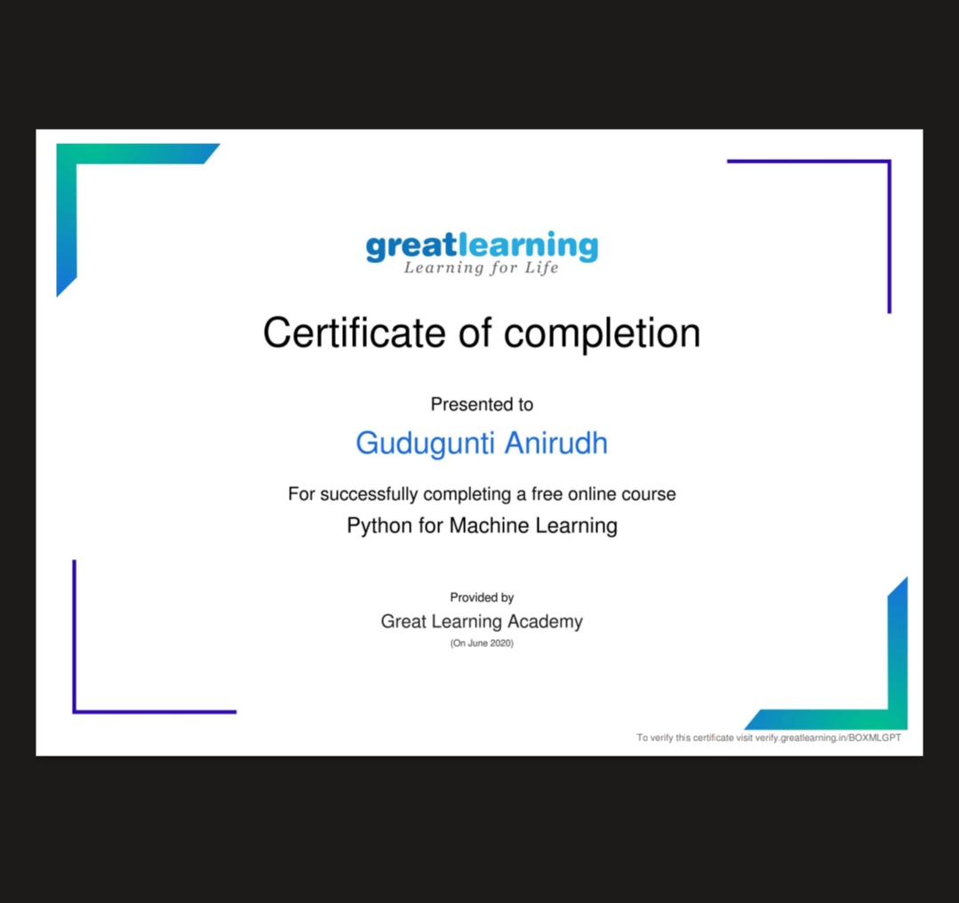

: I have successfully completed a free online course in python for machine learning through great learning academy. I received the certificate of completion.

Coding Challenges Details:

Problem 1: (using C) program to rotate an array by N positions.

